**BUBBLE SORT**

#include<stdio.h>

#include<stdlib.h>

#include<time.h>

void bubble_sort(int arr[],int n)

{

int temp;

for(int i =0;i<n;i++)

{

for(int j=i+1;j<n;j++)

{

if(arr[i]>arr[j])

{

temp = arr[i];

arr[i] = arr[j];

arr[j] = temp;

}

}

}

}

void bubble_sortTT(int arr[],int n)

{

int temp;

for(int i =0;i<n;i++)

{

for(int j=i+1;j<n;j++)

{

if(arr[i]<arr[j])

{

temp = arr[i];

arr[i] = arr[j];

arr[j] = temp;

}

}

}

}

int main()

{

clock_t start, stop;

int n;

start = clock();

printf("Enter the number of elements:\n");

scanf("%d",&n);

int arr[n];

int r;

srand(time(NULL));

for(int i=0;i<n;i++){

r = rand();

arr[i]=r;

}

bubble_sortTT(arr,n);

printf("UnSorted array is:\n");

for(int i=0;i<n;i++){

printf("%d \n",arr[i]);

}

printf("\n\n\n\n\n\n\n");

start = clock();

bubble_sort(arr,n);

stop = clock();

printf("Sorted array is:\n");

for(int i=0;i<n;i++)

{

printf("%d\n",arr[i]);

}

double time = (double)(stop - start) / CLOCKS_PER_SEC;

printf("the exicution time of the program is %f seconds",time);

}

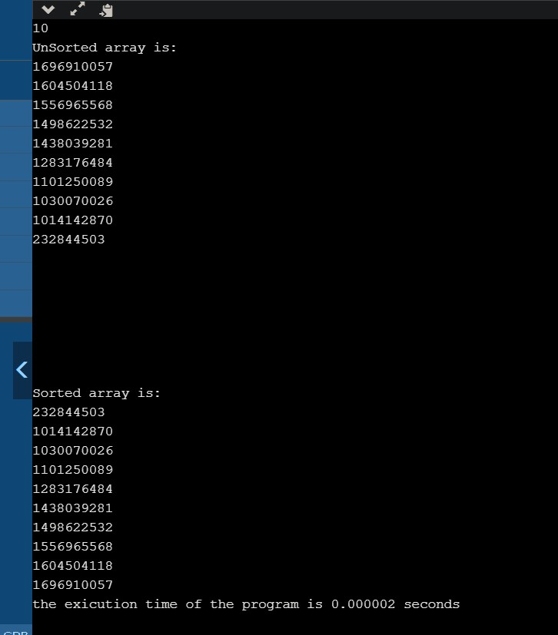

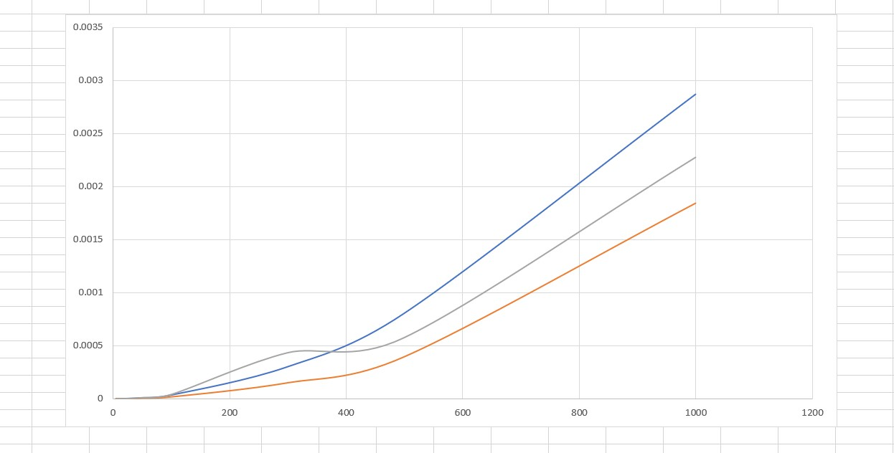

**SELECTION SORT**

#include <stdio.h>

#include<stdlib.h>

#include<time.h>

void swap(int *xp, int *yp)

{

int temp = *xp;

*xp = *yp;

*yp = temp;

}

void selectionSort(int arr[], int n)

{

int i, j, min_idx;

for (i = 0; i < n-1; i++)

{

min_idx = i;

for (j = i+1; j < n; j++)

if (arr[j] < arr[min_idx])

min_idx = j;

swap(&arr[min_idx], &arr[i]);

}

}

void selectionSortTT(int arr[], int n)

{

int i, j, min_idx;

for (i = 0; i < n-1; i++)

{

min_idx = i;

for (j = i+1; j < n; j++)

if (arr[j] > arr[min_idx])

min_idx = j;

swap(&arr[min_idx], &arr[i]);

}

}

int main()

{

clock_t start, stop;

int n;

printf("Enter the number of elements:\n");

scanf("%d",&n);

int arr[n];

int r;

srand(time(NULL));

for(int i=0;i<n;i++){

r = rand();

arr[i]=r;

}

selectionSortTT(arr, n);

printf("UnSorted array is:\n");

for(int i=0;i<n;i++){

printf("%d \n",arr[i]);

}

printf("\n\n\n\n\n\n\n");

start = clock();

selectionSort(arr, n);

printf("Sorted array: \n");

stop = clock();

for(int i=0;i<n;i++){

printf("%d \n",arr[i]);

}

double time = (double)(stop - start) / CLOCKS_PER_SEC;

printf("the exicution time of the program is %f seconds",time);

return 0;

}

